Exercise 1: Setting Up JUnit

Source Code

Calculator.java
public class Calculator {
public int add(int a, int b) {
return a + b;
}
}

CalculatorTest.java
import static org.junit.Assert.assertEquals;
import org.junit.Test;
public class CalculatorTest {
@Test
public void testAddition() {
Calculator calculator = new Calculator();
int result = calculator.add(10, 20);
assertEquals(30, result);
}
}

Output
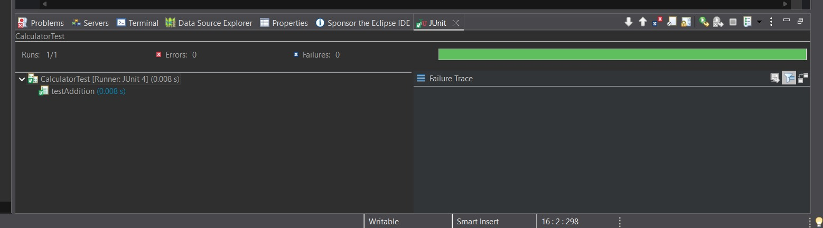
Result:
The JUnit environment was configured successfully, and the test case executed without any errors.

Exercise 3: Assertions in JUnit

Source Code

AssertionsTest.java
import static org.junit.Assert.*;
import org.junit.Test;
public class AssertionsTest {
@Test
public void testAssertions() {
assertEquals(5, 2 + 3);
assertTrue(5 > 3);
assertFalse(5 < 3);
String text = null;
assertNull(text);
Object obj = new Object();
assertNotNull(obj);
}
}

Output
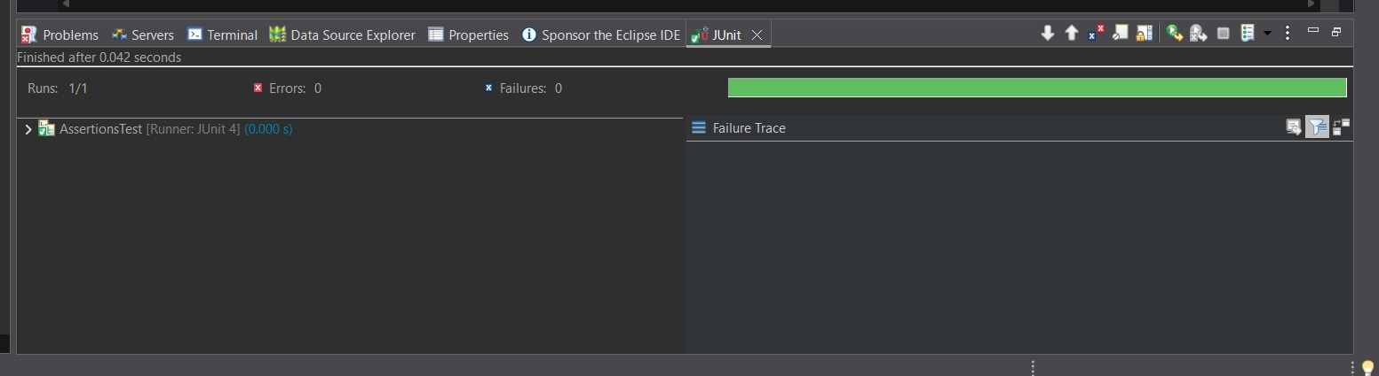
Result:
Different JUnit assertion methods such as assertEquals(), assertTrue(), assertFalse(), assertNull(), and assertNotNull() were executed successfully, confirming that all test cases passed.

Exercise 4: Arrange-Act-Assert (AAA) Pattern, Test Fixtures, Setup and Teardown Methods in JUnit

Source Code

Calculator.java

public class Calculator {

public int add(int a, int b) {

return a + b;

}

public int multiply(int a, int b) {

return a * b;

}

}

CalculatorAAATest.java
import static org.junit.Assert.assertEquals;
import org.junit.After;
import org.junit.Before;
import org.junit.Test;
public class CalculatorAAATest {
private Calculator calculator;
@Before
public void setUp() {
calculator = new Calculator();
System.out.println("Setup completed");
}
@After
public void tearDown() {
calculator = null;
System.out.println("Teardown completed");
}
@Test
public void testMultiply() {
// Arrange
int num1 = 6;
int num2 = 5;
// Act
int result = calculator.multiply(num1, num2);
// Assert
assertEquals(30, result);
}
}

Explanation of AAA Pattern
- Arrange: Prepare the required objects and test data.
- Act: Execute the method being tested.
- Assert: Verify that the actual result matches the expected result.

Output
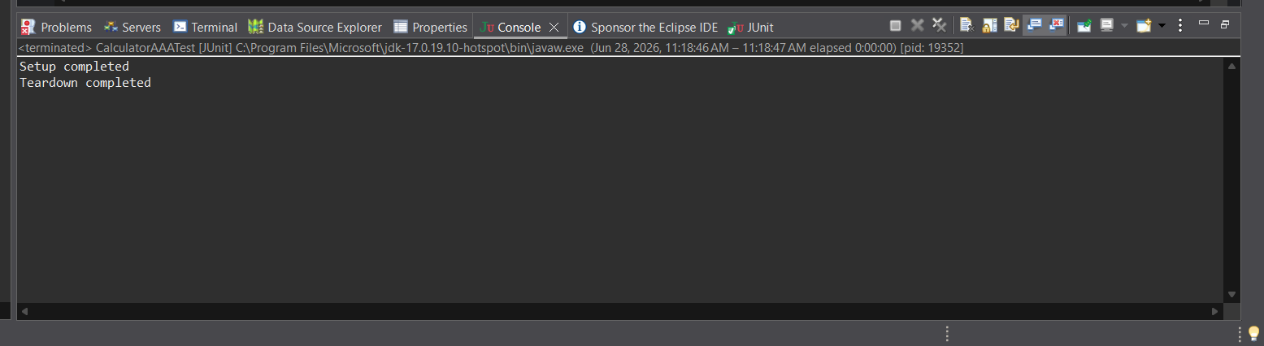
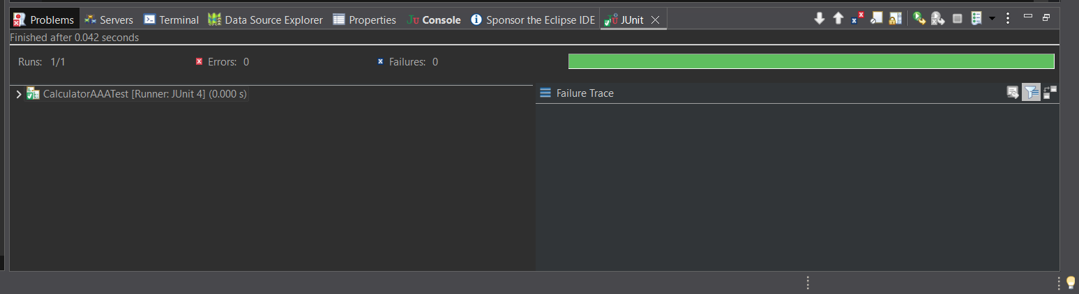
Result
The Arrange-Act-Assert (AAA) pattern was implemented successfully using JUnit. The @Before method initialized the test object before execution, and the @After method cleaned up the resources after the test. The test executed successfully without any failures or errors.

